Introduction to Management Week 4 Study Group Sem 2

# Discussion

Chain of command: the right to give command, take actions and make decision on everywhere below them in the chain

Line function: everything that

Departmentalisation types:

* Function
* Product
* Customer
* Geographic
* Matrix

Organisation structure vs process:

Job Design: (job specialisation, rotation, enlargement, enrichment)

Core job characteristics()

Mechanistic Organisations

Organic Organisations

Internal Motivation

JCM Model

Week 3:

Setting SMART Goals

Set goals, develop commitment, develop effective action plan, track progress, take corrective action

Option-based planning (slack resources)

Mission vs vision vs strategic plans

Mission: overall company goal

Vision: brief statement for existence purpose

Strategic Plan: overall plan for 2-5 years

Management by objectives (MBO): done by middle level managers (linked with technical plan in diagram)

Managers plan stuff using employee’s input

1. The organisation's overall objectives and strategies are formulated.
2. Major objectives are allocated to divisional and departmental units.
3. Unite managers collaboratively set specific objectives for their units with their managers.
4. Specific objectives are collaboratively set with all department members.
5. Action plans, defining how objectives are to be achieved, are specified and agreed upon by managers and employees.
6. The action plans are implemented.
7. Progress towards objectives in periodically reviewed and feedback is provided.
8. Successful achievement of objectives is reinforced by performance-based rewards.

Maximising vs. satisficing

Operational plans: (single use, standing, budget planning)

Day to day plans made by first level managers

Standing plan types (policies, procedures, rules and regulation)

Rational decision making defn:

Group decision making (adv vs disadv)

Benefits of planning:

Nominal group, delphi, electronic brainstorming comparison and differences

Specific goals: says all the steps and details to reach objective

Directional Goals: just gives a general direction (following Vision)

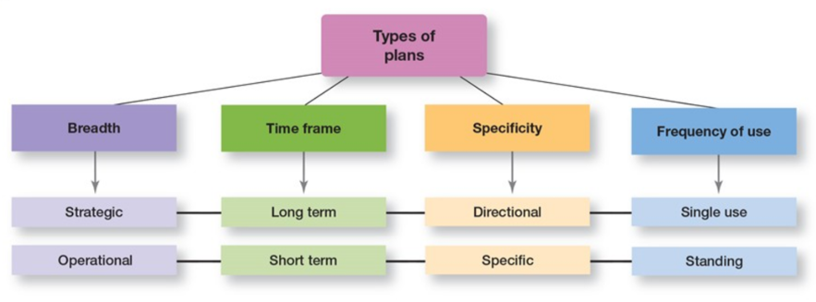

# My notes

**Formal and informal planning**

* Planning can be either formal or informal
* Informal planning is where nothing is written down and there is little or no sharing of goals with others in the organisation.
* Formal planning is where specific goals covering a period of years are defined. These goals are written down and shared with organisational members to reduce ambiguity and create a common understanding about what needs to be done.

**Importance of planning**

* Provides direction
* Reduces uncertainty
* Minimises waste and redundancy
* Establishes the goals or standards that are used in controlling
* Provides a starting point for further managerial actions

**What is planning?**

* Planning involves setting the organisation's goals, establishing strategies for achieving those goals, and developing plans to integrate and coordinate work activities. It is concerned with the end (what is to be done) and the means (how it is to be done).
* Goals are desired outcomes or targets for individuals, groups and entire organisations.
* They provide the direction for all management decisions and form the criterion against which actual work accomplishments can be measured.
* Remember to be **SMARTER:**
  + Financial goal: e.g. Earn $1.4 million profit before tax
  + Strategic goal: e.g. Swinburne to become a world class university creating social and economic impact through science, technology and innovation.

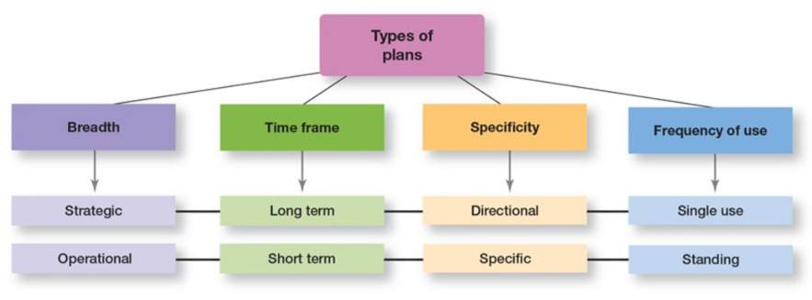

**Approaches to setting goals**

* Goals provide the direction for all management decisions and actions and form the criteria against which actual accomplishments are measured.
* Traditional goal setting is an approach to setting goals in which top managers set goals that then flow down through the organisation and become sub goals for each organisations area.
* Management by objectives is the process of setting mutually agreed upon goals and using those goals to evaluate employee performance.

**Who makes plans?**

* A formal planning department takes sole responsibility for planning in the traditional approach to planning.
* Participatory planning includes the people who will be affected by plans and/or whose help is needed to implement them.

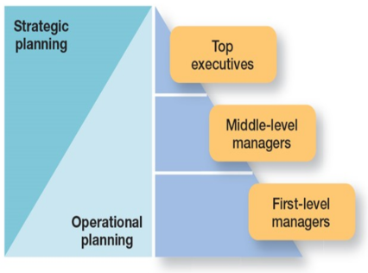

**Steps in goal setting**

* Review the organisation's mission. The mission is the purpose of an organisation.
* Evaluate available resources.
* Determine the goals.
* Write down the goals and communicate them to all who need to know.
* Review results to see whether goals are being met.

**Contingency Factors in Planning**

* Three contingency factors affect planning:
  + Level in the organisation
  + Degree of environmental uncertainty (e.g. Uncertain environment, specific but flexible plans)
  + Length of future commitments (more a plan affects future commitment, the longer the time frame that managers should plan).

**Planning tools and techniques**

* Approaches to planning:
  + Traditional goal setting
  + Management by objectives (MBO)
  + Gannt Chart

**Management by objectives**

* A process of setting mutually agreed-upon goals and using those goals to evaluate employee performance.

1. The organisation's overall objectives and strategies are formulated.
2. Major objectives are allocated to divisional and departmental units.
3. Unite managers collaboratively set specific objectives for their units with their managers.
4. Specific objectives are collaboratively set with all department members.
5. Action plans, defining how objectives are to be achieved, are specified and agreed upon by managers and employees.
6. The action plans are implemented.
7. Progress towards objectives in periodically reviewed and feedback is provided.
8. Successful achievement of objectives is reinforced by performance-based rewards.

**Gannt chart**

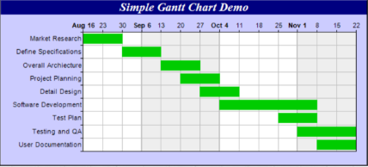

**Strategic planning tools, & techniques**

* Environmental scanning involves screening large amounts of information to anticipate and interpret changes in the environment.
* Benchmarking/competitor intelligence is a technique that makes use of external comparisons to better evaluate an organisation's current performance and identify possible actions for the future.
* Forecasting is a technique that uses quantitative or qualitative information to predict outcomes.

**How can managers plan effectively in dynamic environments?**

* In an uncertain environment, managers should develop plans that are specific but flexible.
* To be useful, plans need some specificity, but they should not be cast in stone.
* Managers need to recognise that planning is an ongoing process.
* The plans serves as a road map even though the destination may be changing constantly due to dynamic market conditions.
* Effective planning in dynamic environments means flattening the organisational hierarchy as the responsibility for establishing goals and developing plans is pushed to lower organisational levels, since there is little time for goals and plans to flow down from the top.